**CAKE BOOKING SYSTEM**

ROLL NO : 1946

NAME : KOKILA PILLAI

INTRODUCTION

* Online cake ordering system project has been developed on PHP and MySQL. It contains Admin and customer login.
* Online cake order is a web based application which enable customers to order cakes through online. The internet users are increasing rapidly, that’s why this project online cake ordering system for getting the orders from customers. This application not only improves customers experiences but also eases the workload on the employees of the cake shop.
* It would be comfortable for the customers to have an online cake ordering system. It would be free for users, they can see the homepage gallery and can select the cake they want and make payment for it. It will reduce the purchasing time for the customers. This system will surely enhance the image of the cake and customer satisfaction will be more.

REQUIREMENTS

* SOFTWARE REQUIREMENTS:
* 1.HTML
* 2. CSS
* 3.PHP
* BACKEND SOFTWARE TOOL
* MySQL

USERS IN THE SYSTEM

* **ADMIN** : The admins are super users where they manage the web application, Admin can add cake details, delete cake, view list of cakes, check registered users list ,view customer report.
* **CUSTOMER** : The customer should register to the system by entering their profile details. Then he can login into the system. customer can view list of cakes available, search cakes.

MODULES OF ONLINE CAKE ORDER

* **LOGIN MODULE** : this is the login form, where customer and ADMIN can login into the system.
  + Features of login module:
    - Customer can register new login records.
    - Customer can see the login details.
* Only customer can edit and update the record of the login.

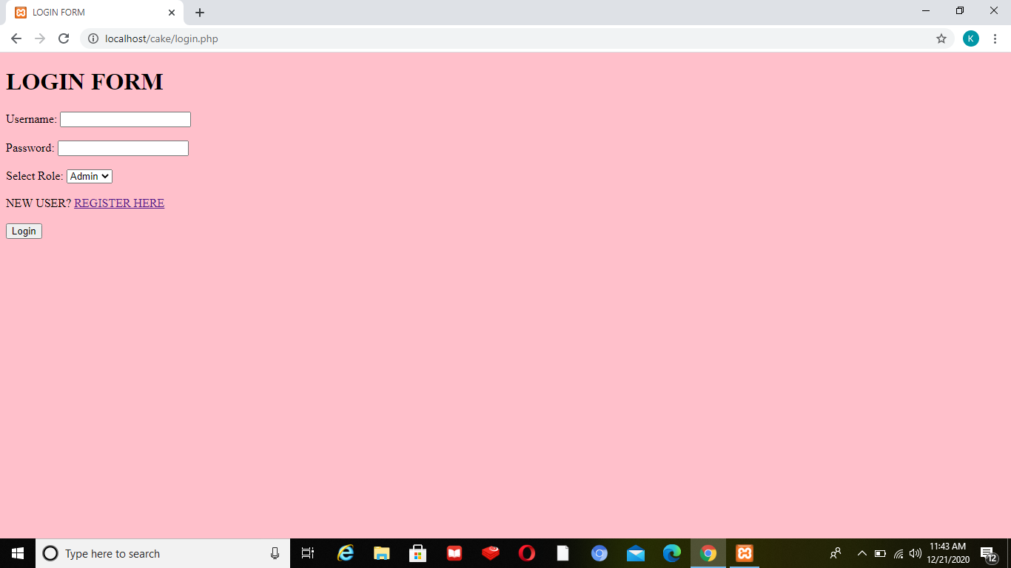

REGISTRATION FORM FOR NEW USER

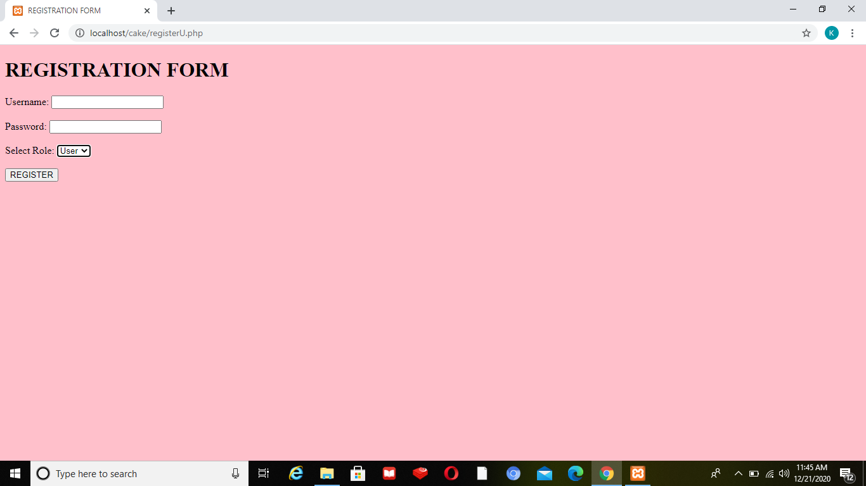

ADMIN LOGIN

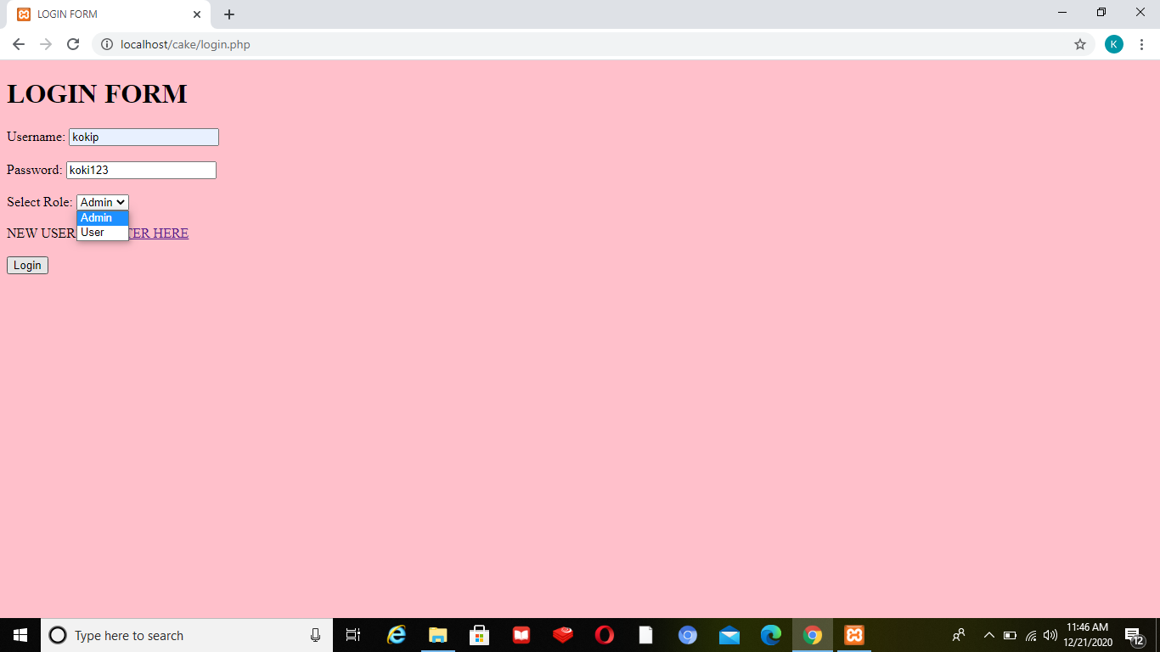

ADMIN PANEL

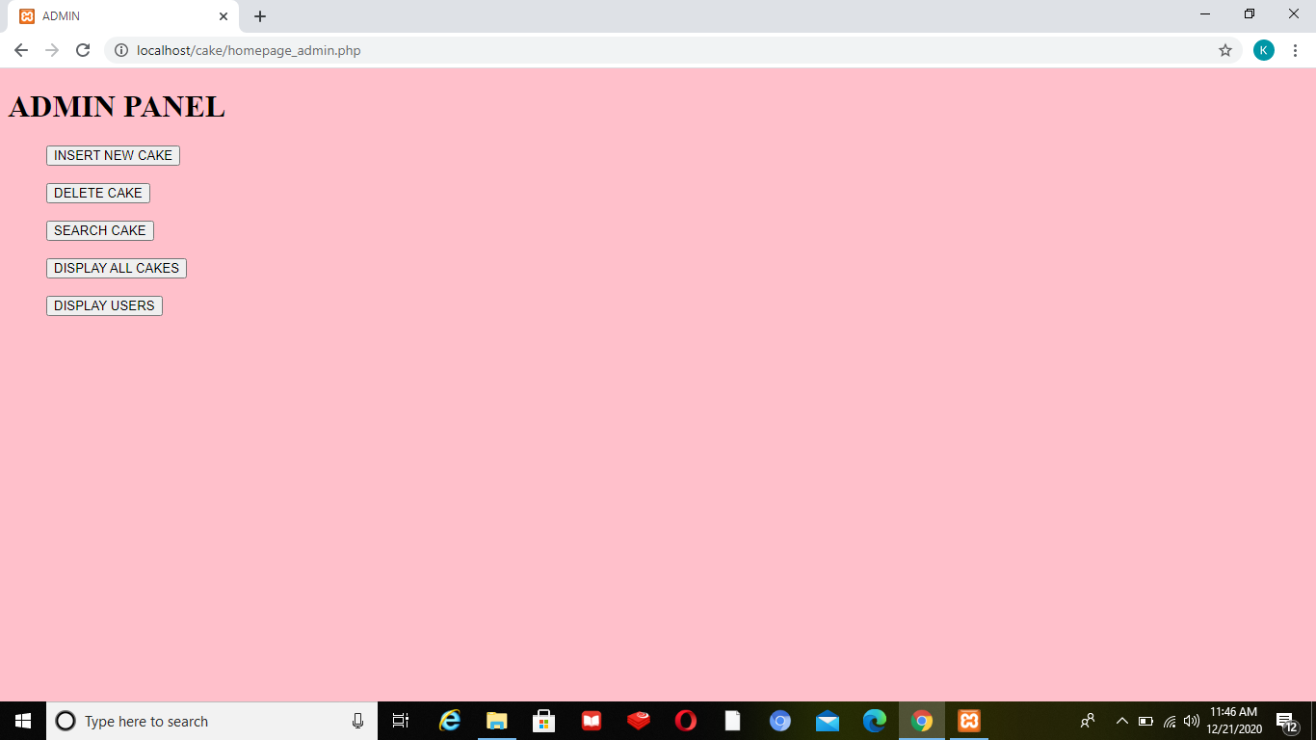

DISPLAY CAKES

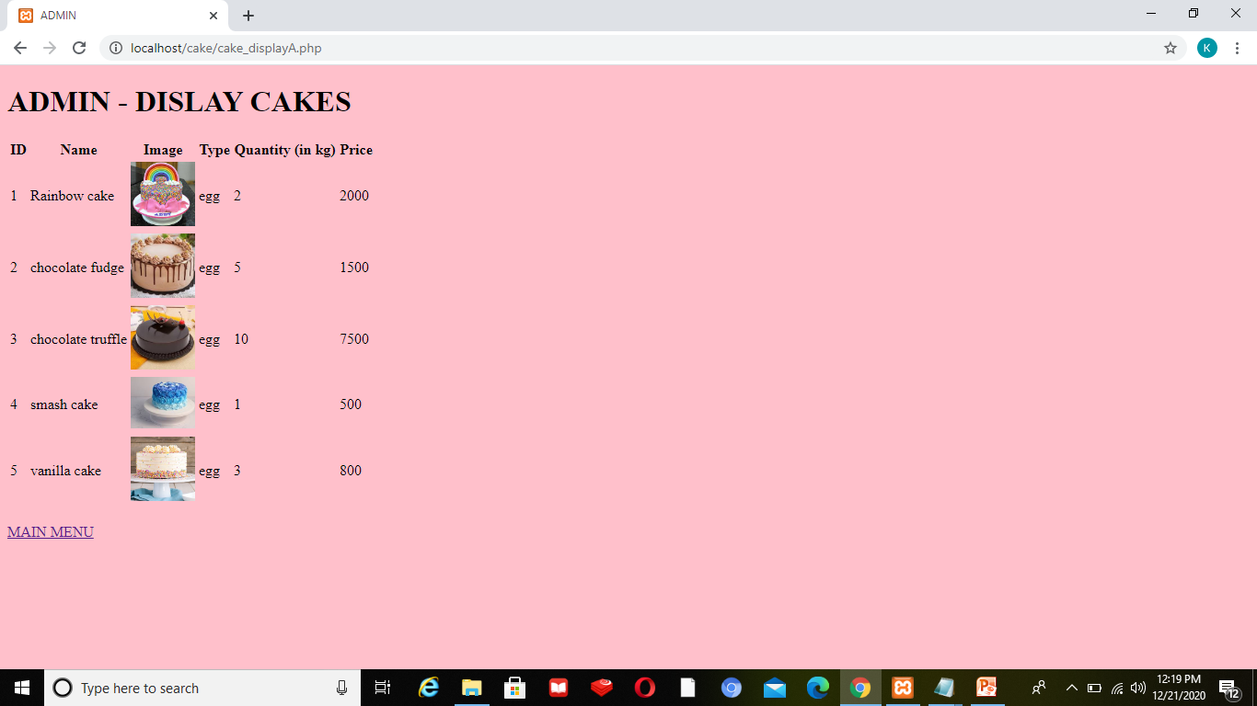

LIST OF REGISTERED USERS LIST

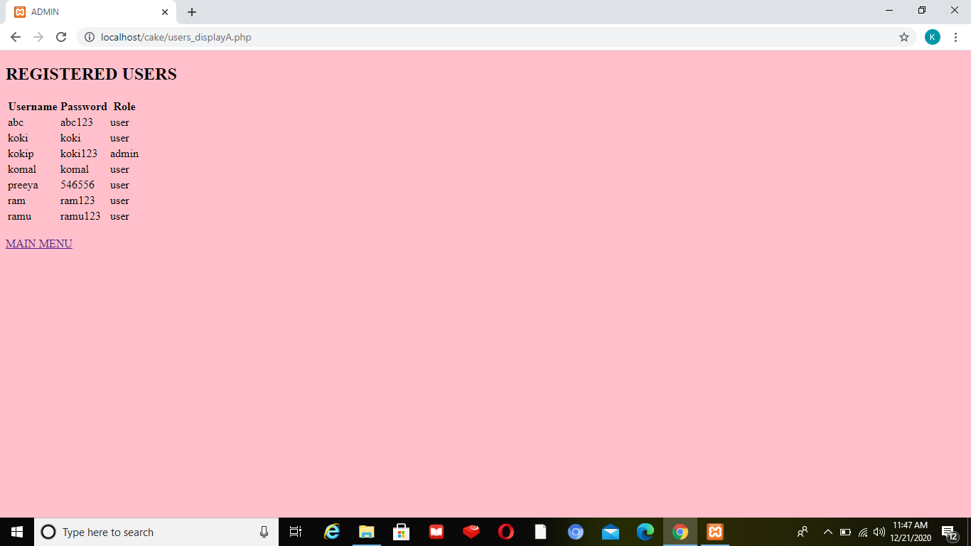

ADMIN-SEARCH CAKE  
by CAKE ID

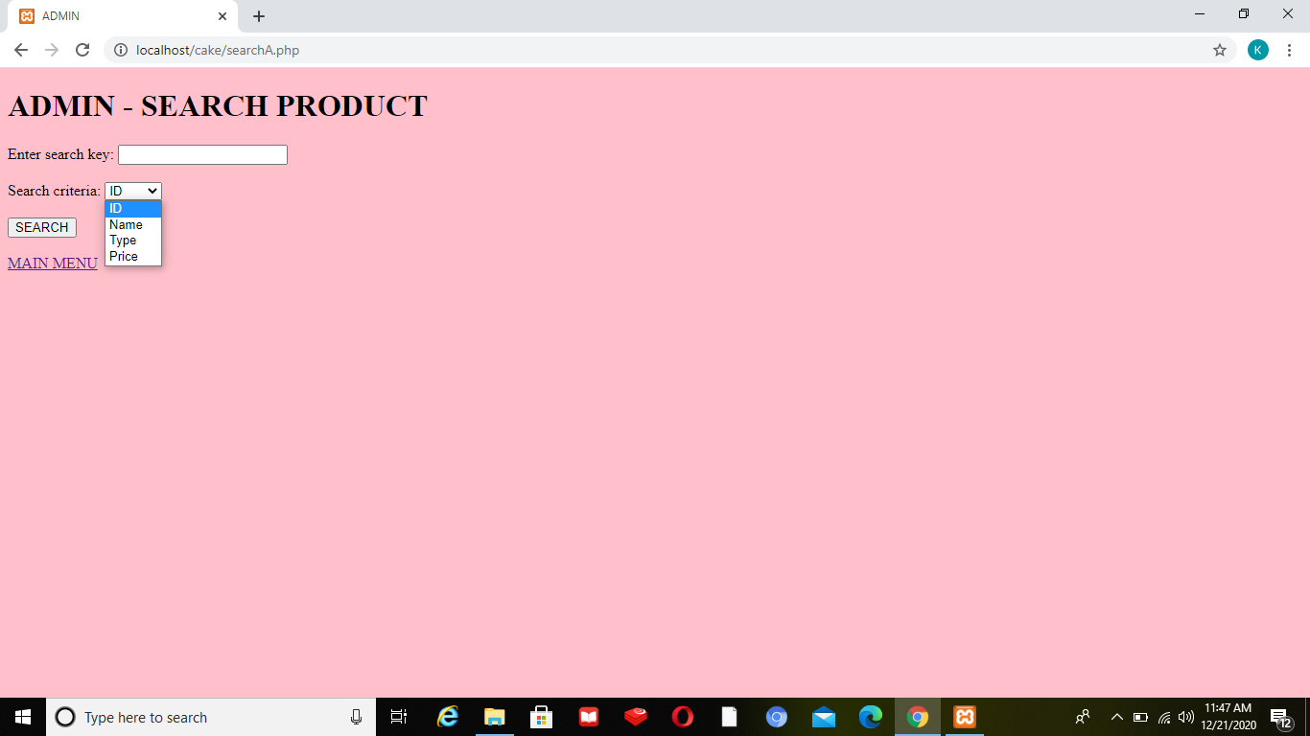

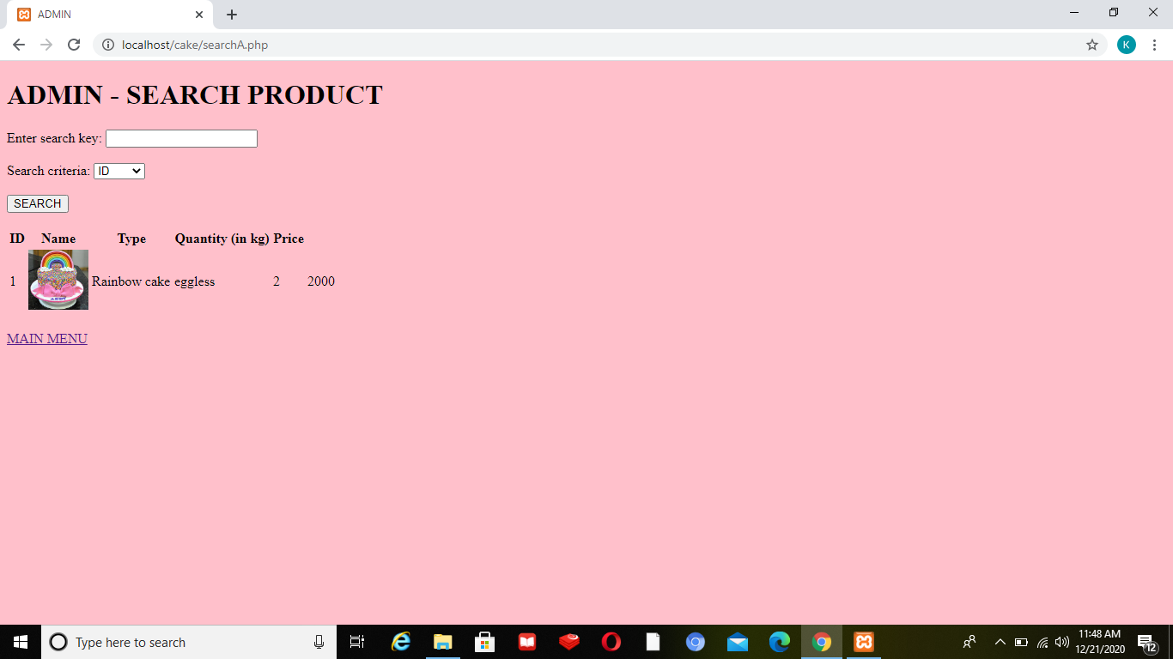

ADMIN-SEARCH CAKE  
by CAKE NAME

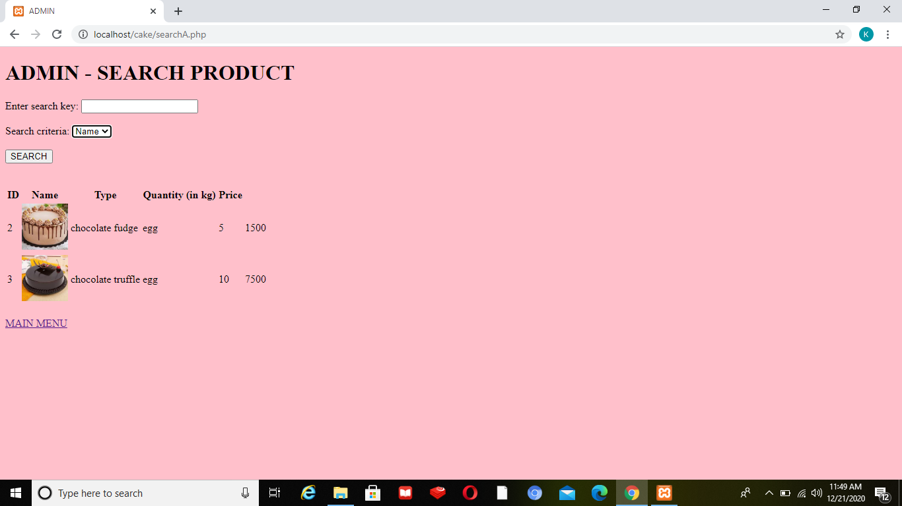

By CAKE TYPE

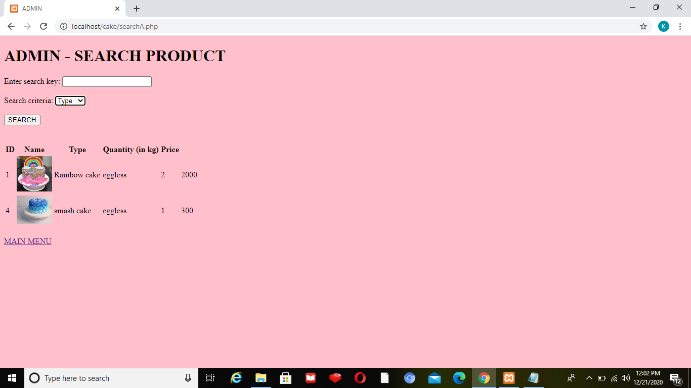

By CAKE PRICE

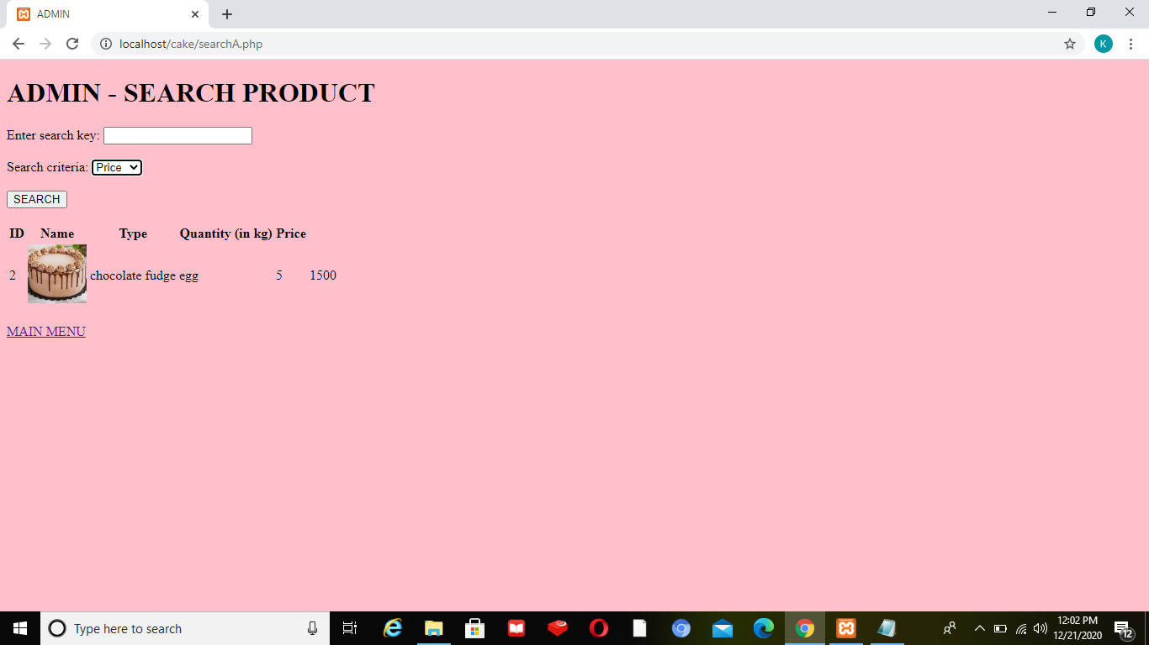

ADMIN-INSERT NEW PRODUCT

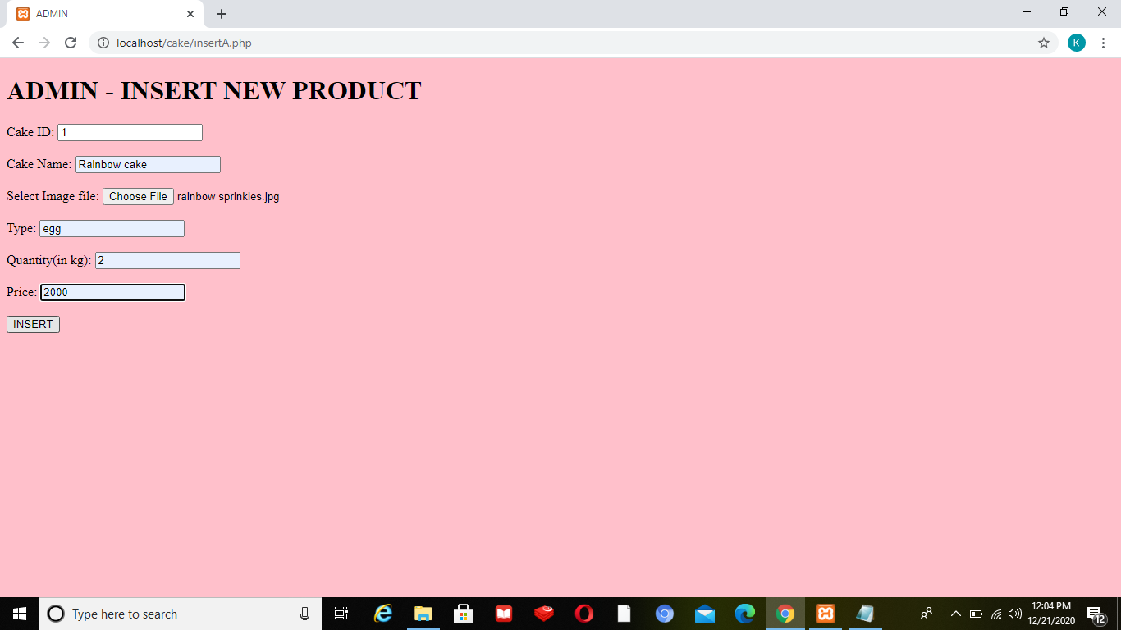

ADMIN-DISPLAY CAKES

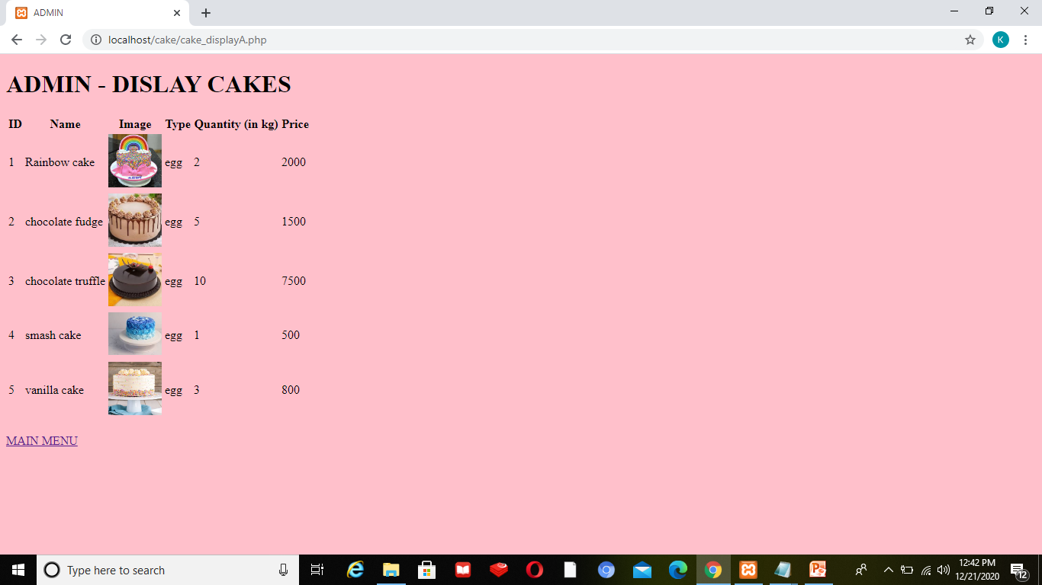

ADMIN-DELETE CAKE

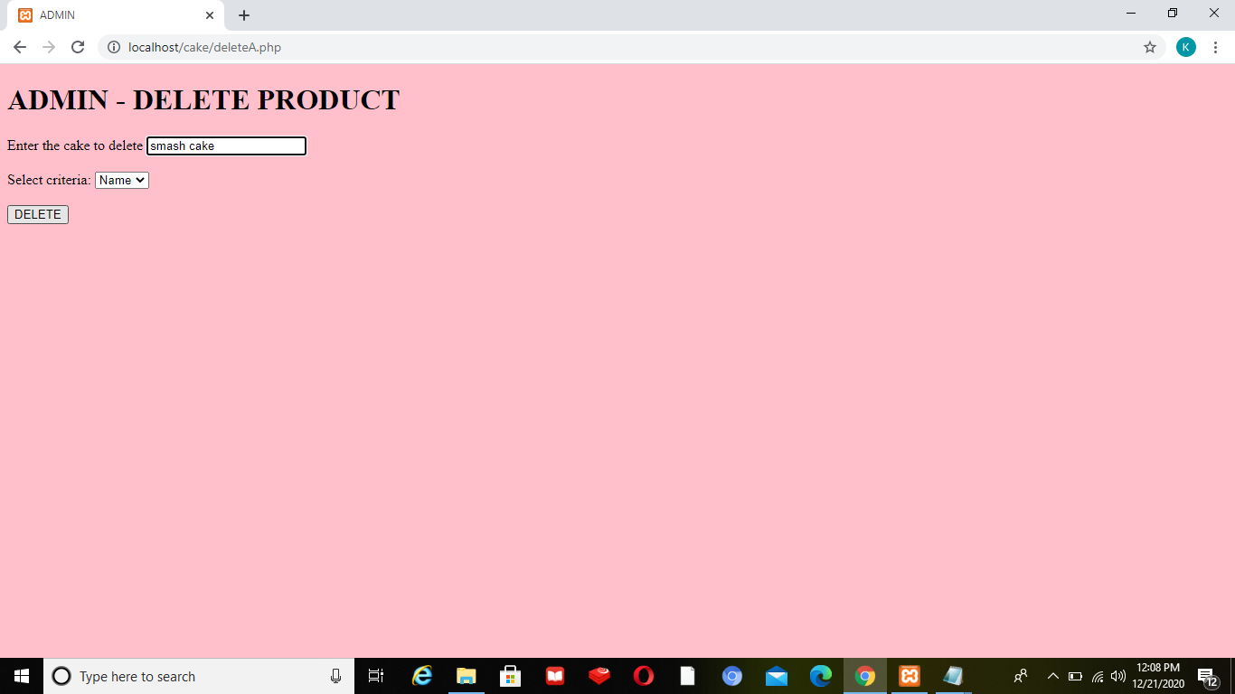

DELETE  
OUTPUT SCREEN

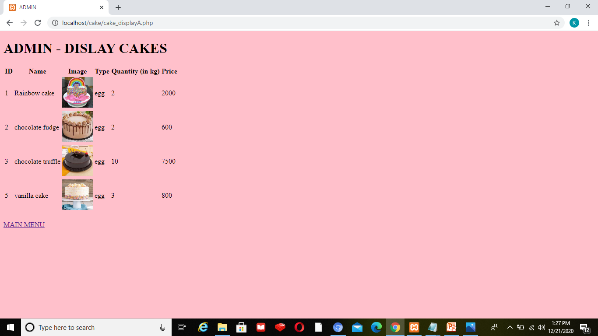

USER-HOMEPAGE

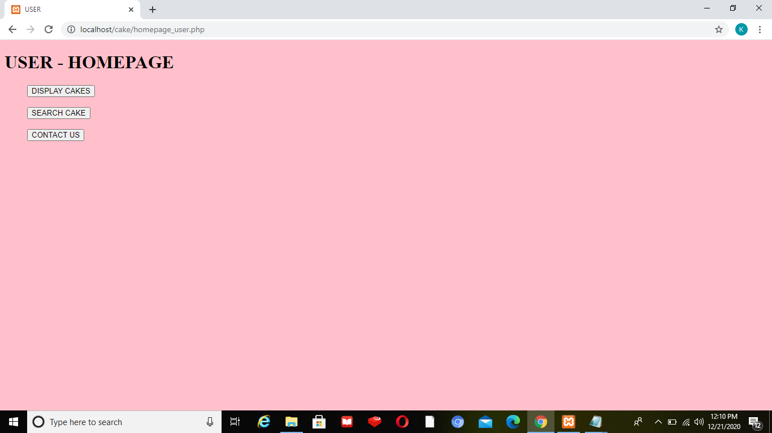

USER-DISPLAY CAKES

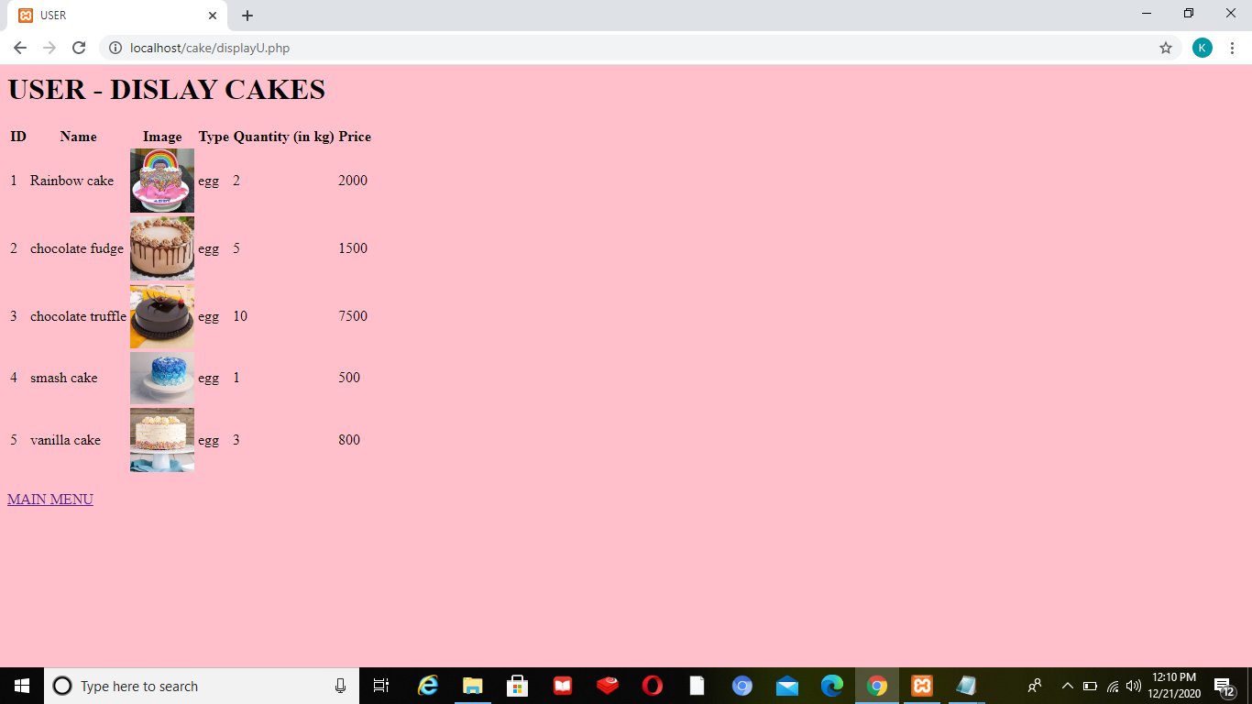

USER-SEARCH PRODUCT

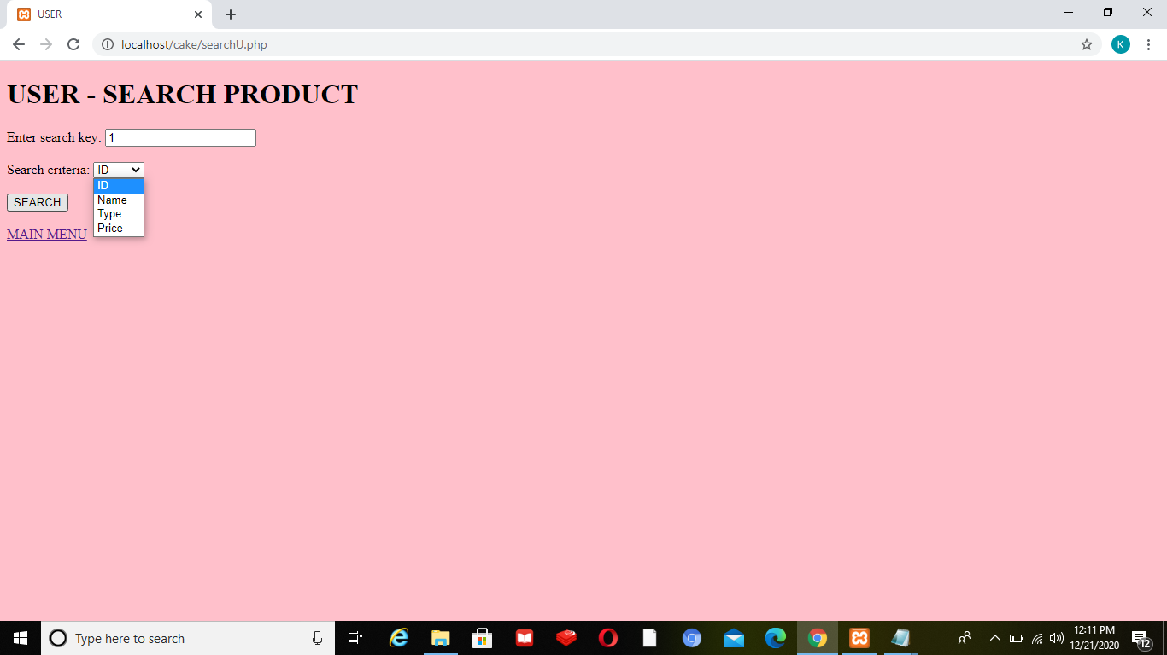

SEARCH CAKE   
by cake id,name,price,type

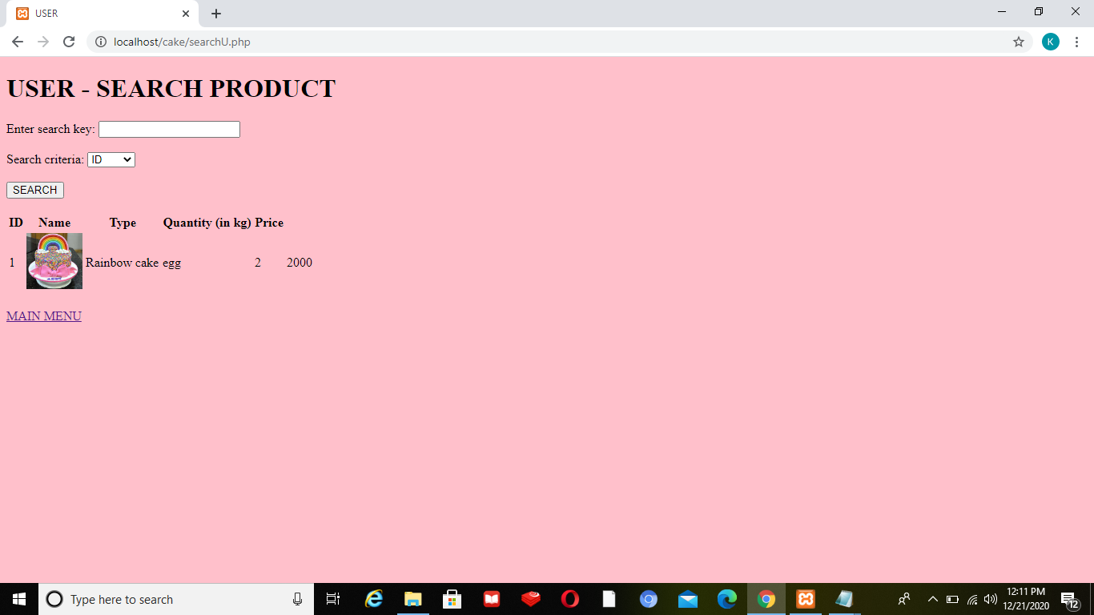

CONTACT US

